**NAME – KARAN DAS**

**USER ID – 34763**

**MAIL-** [**karannnx20@gmail.com**](mailto:karannnx20@gmail.com)

**Date – 12th Aug 2025**

**Topic Assignment:**

**Execute-MSI - Installation and Uninstallation**

Execute-MSI is a command used within the PSAppDeployToolkit for installing and uninstalling MSI packages. It provides a standardized way to handle MSI installations and uninstallation through poweshell.

Install Example:

Execute-MSI -Action 'Install' -Path 'Cloudflare_WARP_2025.4.943.0.msi' -Parameter '/QN'

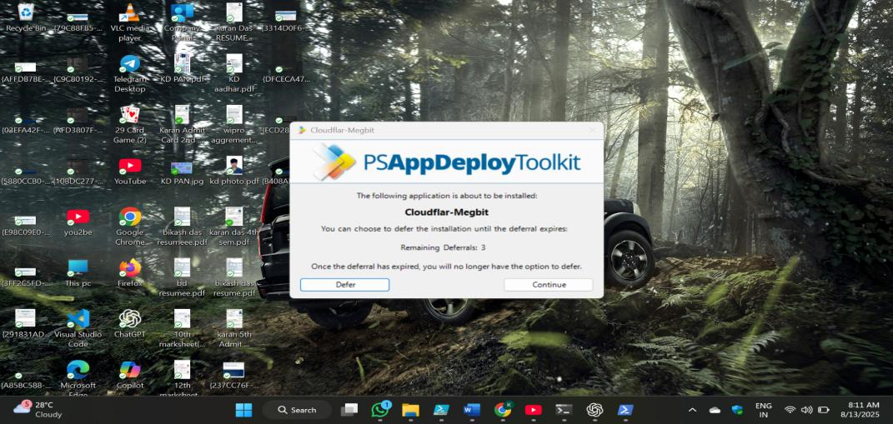

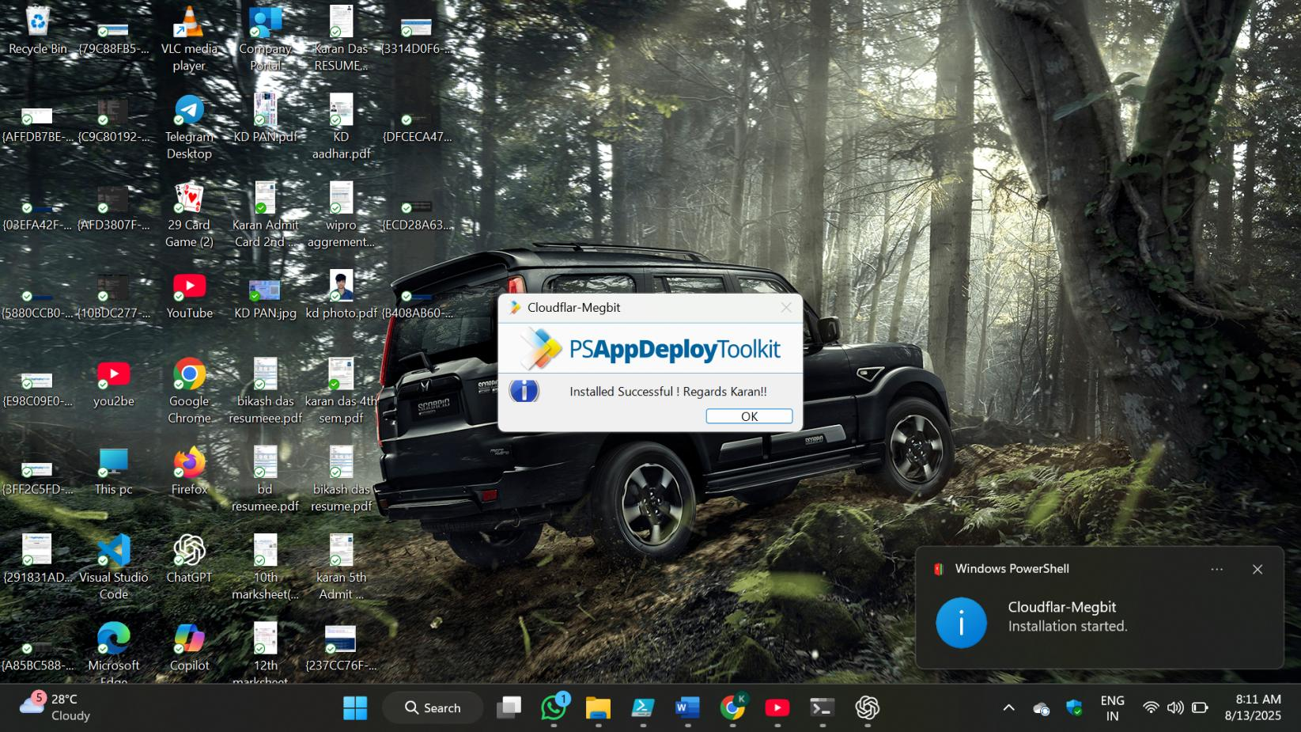

Uninstall Example:

Execute-MSI -Action 'Uninstall' -Path 'Cloudflare_WARP_2025.4.943.0.msi' -Parameter '/QN'

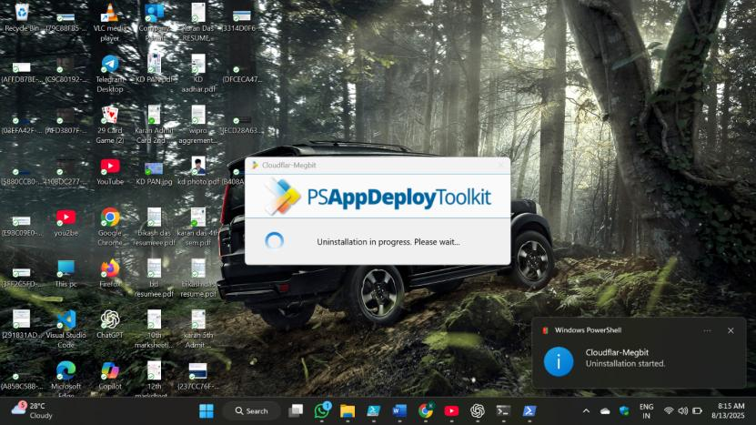

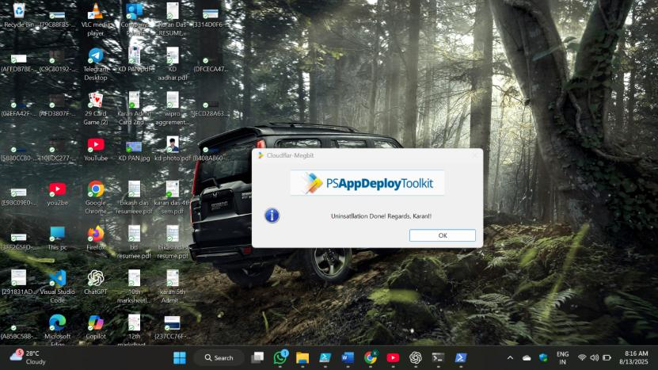

**Execute-Process**

Executes a process, e.g. a file included in the Files directory of the App Deploy Toolkit, or a file on the local machine. Provides various options for handling the return codes

Install:-

Execute-Process -Path 'KD-Softw.exe' -Parameters '/S' -WindowStyle 'Hidden'

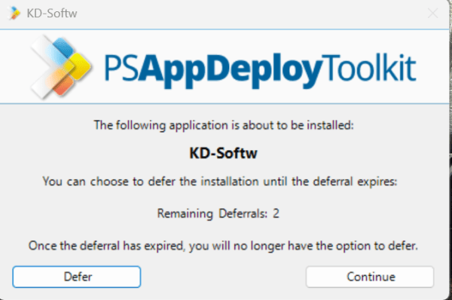

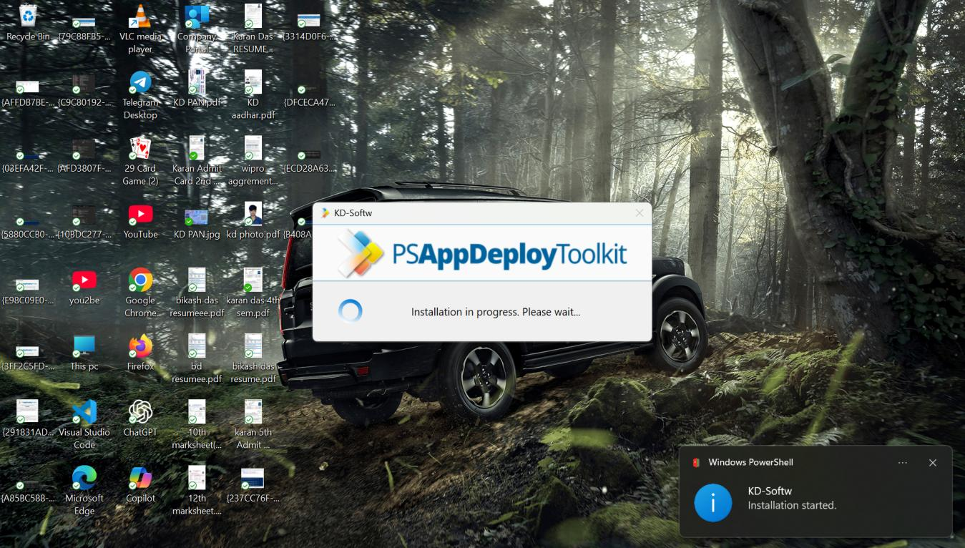

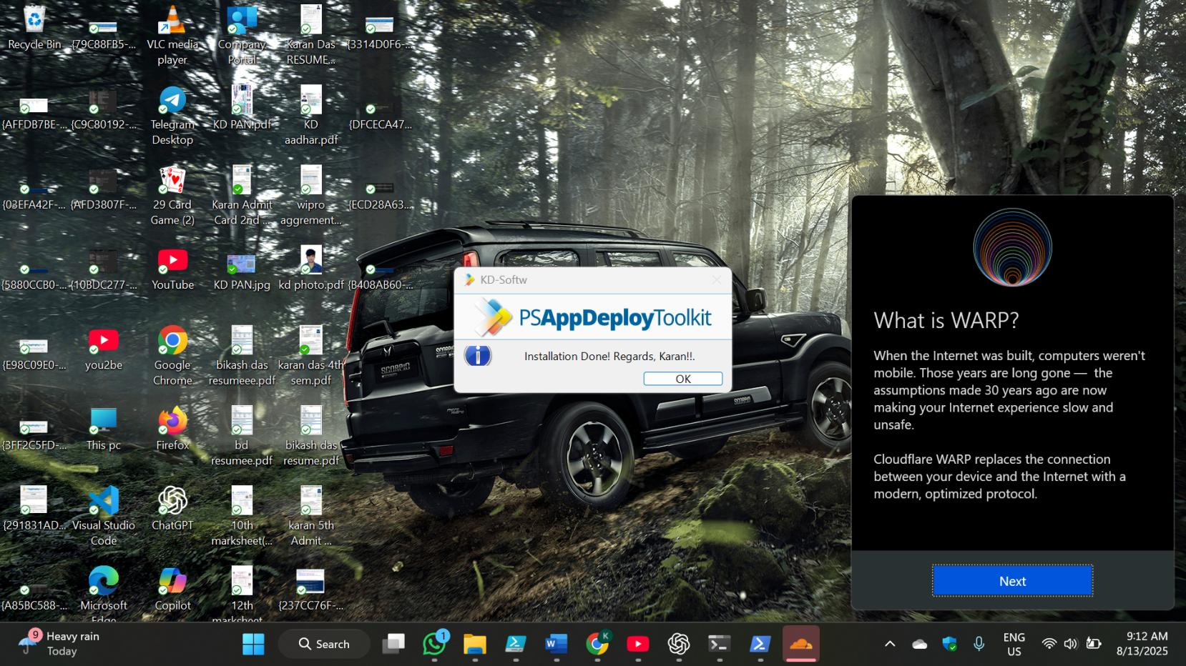

Uninstall:-

Execute-Process -Path "'KD-Softw.exe " -Parameters "/uninstall /quiet /norestart"

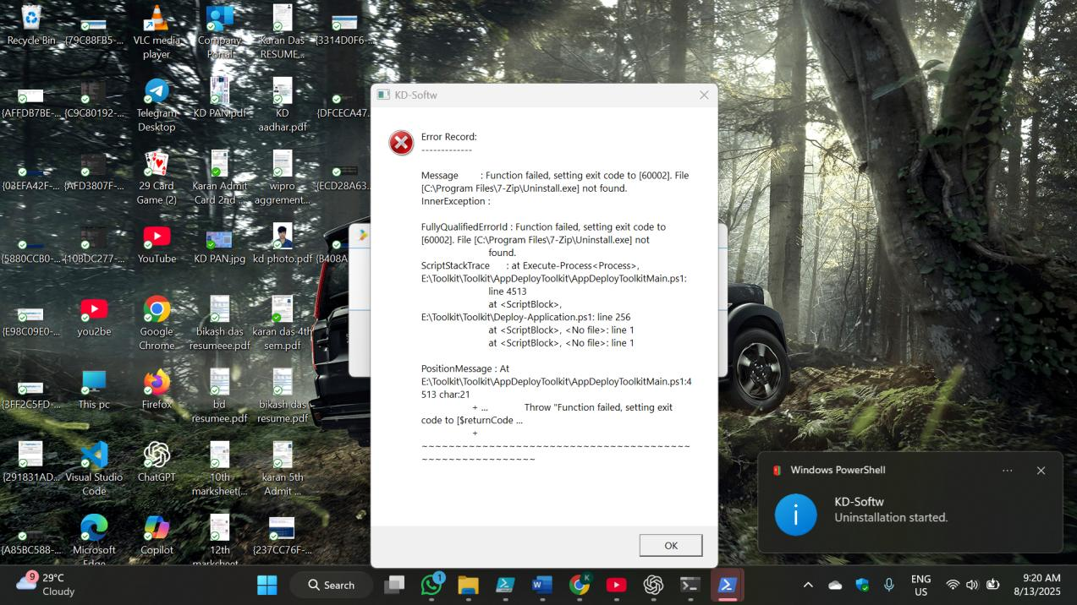

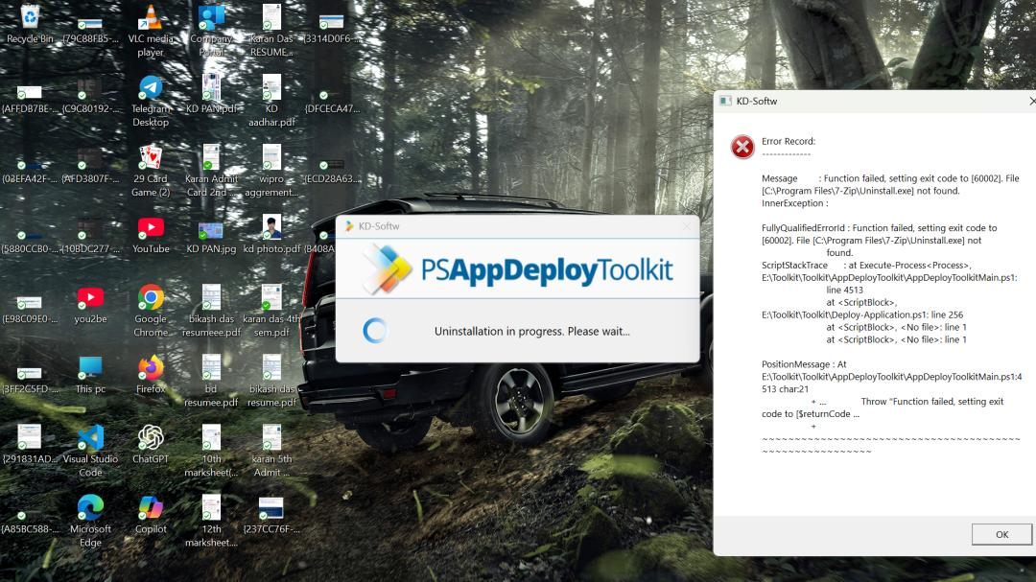

**Execute-MSP**

Executes an MSP file using the same logic as Execute-MSI.

**Execute-MSP -Path "OfficeUpdate.msp"**

**Install-MSUPdates**

The command Install-MSUPdates is related to installing updates, specifically Microsoft updates. It can refer to either a PowerShell function or a Windows Update Standalone Installer (.msu) package installation. The context of how to use it depends on whether you are referring to a script or a standalone file.

Install-MSUPatch -Path "Windows10-KB5005565-x64.msu"

**Set-RegistryKey -Key "HKLM\SOFTWARE\Microsoft\Active Setup\Installed Components\MyApp" -Name "StubPath" -Value "powershell.exe -File C:\Scripts\UserConfig.ps1"**

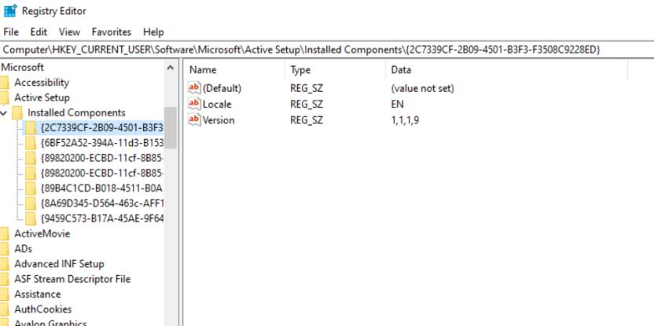

**Copy/Delete/Move File and Folders:-**

Copy:

Copy-Item -Path "E:\Toolkit\Toolkit\Files" -Destination "E:\Powershell"

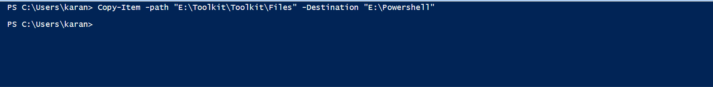

For Delete:-

Remove-Item -Path "E:\fldr for dlt" -Force

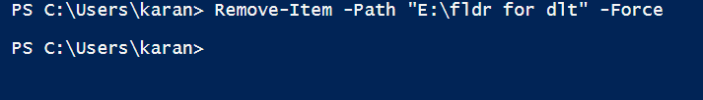

Move:

PS C:\Users\karan> Move-Item -Path "E:\window debugging tools" -Destination "E:\Powershell"

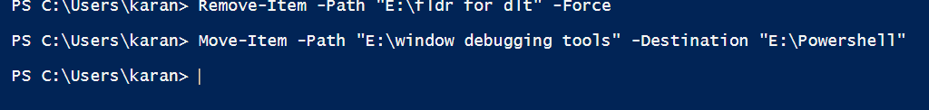

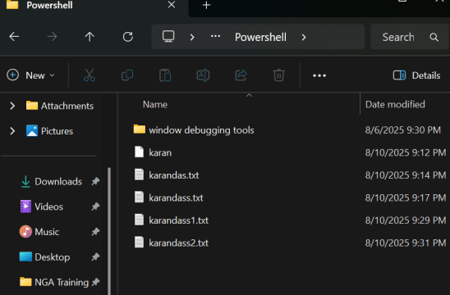

**Create/Delete/Modify Registries**

Create & Set Value:

New-Item -Path "HKCU:\Software\MyApp" -Force  
Set-ItemProperty -Path "HKCU:\Software\MyApp" -Name "Version" -Value "1.0"

Modify Value:

Set-ItemProperty -Path "HKCU:\Software\MyApp" -Name "Version" -Value "2.0"

Remove-Item -Path "HKCU:\Software\MyApp" -Recurse

**Start/Stop Services**

Start Service:

Start-Service means it start the service .

Stop Service:

Stop-Service- it stops the service.